**Experiment No. 08**

* 1. **Experiment Name**

Transient response analysis of a series RL circuit to imitate the terminal fault of an unloaded alternator

* 1. **Objectives**
* To become acquainted with the transient response analysis of a series RL circuit
* To understand the algorithm and generate a MATLAB code for transient response analysis of a series RL circuit
* To get familiar with the procedure of designing and analyzing a power system in MATLAB
  1. **Theory**

A first-order RL circuit is constructed of one resistor and one inductor that are either connected in series by a voltage source or connected in parallel by a current source. It is one of the most basic analogue infinite impulse response electrical filters available.

Thus, the differential equation is, $V_{max}\sin{(ωt+ α)}= iR+L\frac{di}{dt}$

By solving this equation, we obtained,

* 1. **Required apparatus**
* MATLAB
  1. **Algorithm**

1. Start
2. Define system function $i(t)$
3. Provide value of resistance, inductance, frequency, maximum voltage, and angle
4. Calculate the value of current $(i)$
$$i=dsolve(L*diff\left(i\right)+R*i==v.sin\left(2*ωt+ α\right),i\left(0\right)==0)$$

5. Plot and display the diagram
6. End
   1. **Flow chart**

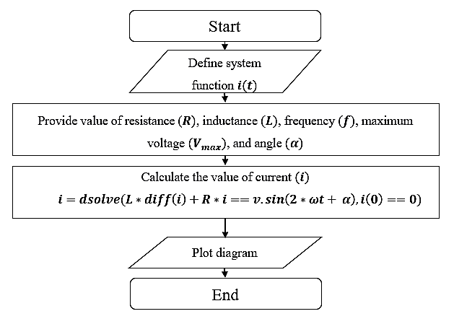

* 1. **MATLAB Code & Output**

clc; %Clears previous data from command window

clear all; %Removes all variables from the current workspace

% Declaring function

syms i(t)

% Assigning values to the variable

R = 50; % Resistance

a = pi/3; % Phase angle

L = 300e-3; % Inductance

f = 100; % Frequency

w = 2*pi*f;

Vm = 100; % Voltage

% Formula

p = dsolve(L*diff(i)+i/R==Vm*sin(w*t+a),i(0)==0)

% Plotting function

ezplot(p)

grid on

% Labeling plot

xlabel('Time(sec)')

ylabel('Current(amp)')

title('Transient response')

**Diagram**



**Fig. 8.1:** Transient response analysis of a series RL circuit

* 1. **Discussion & Conclusion**

In this experiment, we designed an algorithm, flow chart, and programmed a generalized code for given transient response analysis of a series RL circuit. Here, we provided the values from and formulated necessary condition to assign values to variables. The only adjustment to the code we may need is changing the input values of the file to work with. Through this generalized coding format, we easily designed our desired output.